**Task 5. String Deduplication**

1. without vm options

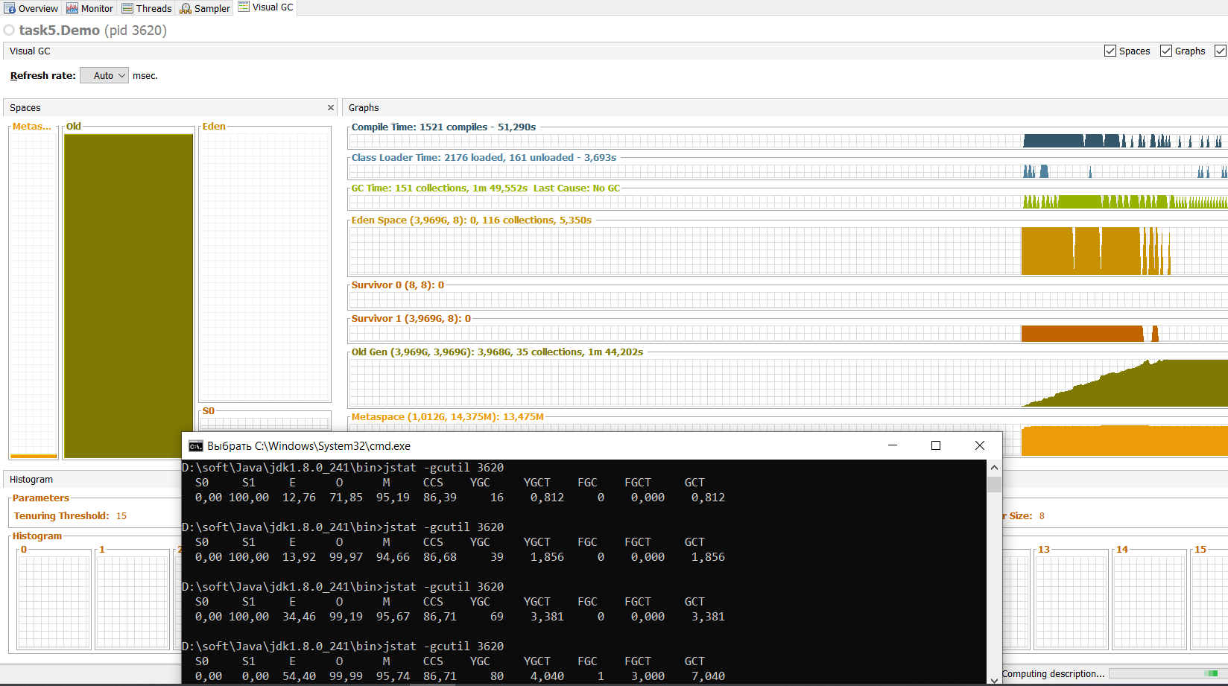

1. -Xmx1024m -XX:+UseG1GC

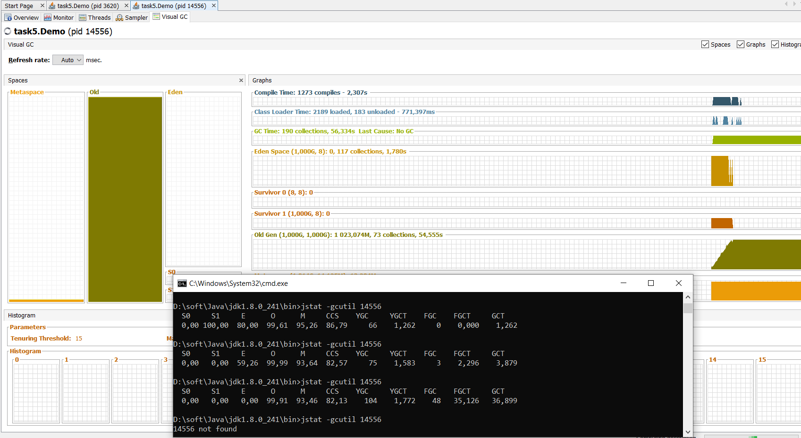

1. -Xmx1024m -XX:+UseG1GC -XX:+UseStringDeduplication -XX:+PrintStringDeduplicationStatistics

